.

**Dept of Artificial Intelligence and Machine Learning** | **Rajalakshmi Engineering College**

137

1. **– Tuple/Set**

**Ex. No. : 8.1 Date:** 27/4/24

.

**Dept of Artificial Intelligence and Machine Learning** | **Rajalakshmi Engineering College**

138

**Register No.:231501017 Name: ANTONY JADRIEN A**

## Binary String

Coders here is a simple task for you, Given string str. Your task is to check whether it is a binary string or not by using python set.

Examples:

Input: str = "01010101010" Output: Yes

Input: str = "REC101" Output: No

**For example:**

|  |  |
| --- | --- |
| **Input** | **Result** |
| 01010101010 | Yes |
| 010101 10101 | No |

**PROGRAM**

str=input()

str=[x for x in str] str=set(str)

c=0

if '0' in str and '1' in str: c+=2

if(c==len(str)):

print("Yes") else:

print("No")

## Output:

.

**Dept of Artificial Intelligence and Machine Learning** | **Rajalakshmi Engineering College**

139

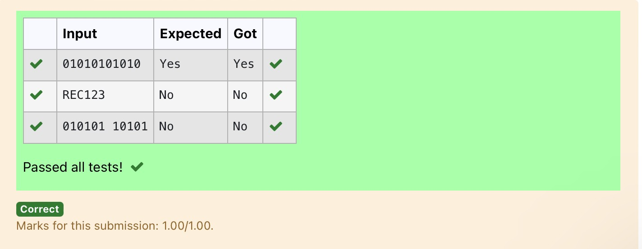

**Ex. No. : 8.2 Date:** 27/4/24

**Dept of Artificial Intelligence and Machine Learning** | **Rajalakshmi Engineering College**

140

**Register No.:231501017 Name: ANTONY JADRIEN A**

**Check Pair**

Given a tuple and a positive integer k, the task is to find the count of distinct pairs in the tuple whose sum is equal to **K**.

Examples**:**

**Input**: t = (5, 6, 5, 7, 7, 8 ), K = 13

**Output**: 2 Explanation:

Pairs with sum K( = 13) are {(5, 8), (6, 7), (6, 7)}.

Therefore, distinct pairs with sum K( = 13) are { (5, 8), (6, 7) }. Therefore, the required output is 2.

For example:

|  |  |
| --- | --- |
| Input | Result |
| 1,2,1,2,5  3 | 1 |
| 1,2  0 | 0 |

**PROGRAM**

s=input() l1=s.split(',') n=int(input()) l2=[]

for i in range(len(l1)): j=i+1

for j in range(len(l1)): if(int(l1[i])+int(l1[j])==n):

l2.append(list[l1[i],l1[j]]) s=set(l2)

print(len(s)//2)

.

Output:

.

**Dept of Artificial Intelligence and Machine Learning** | **Rajalakshmi Engineering College**

141

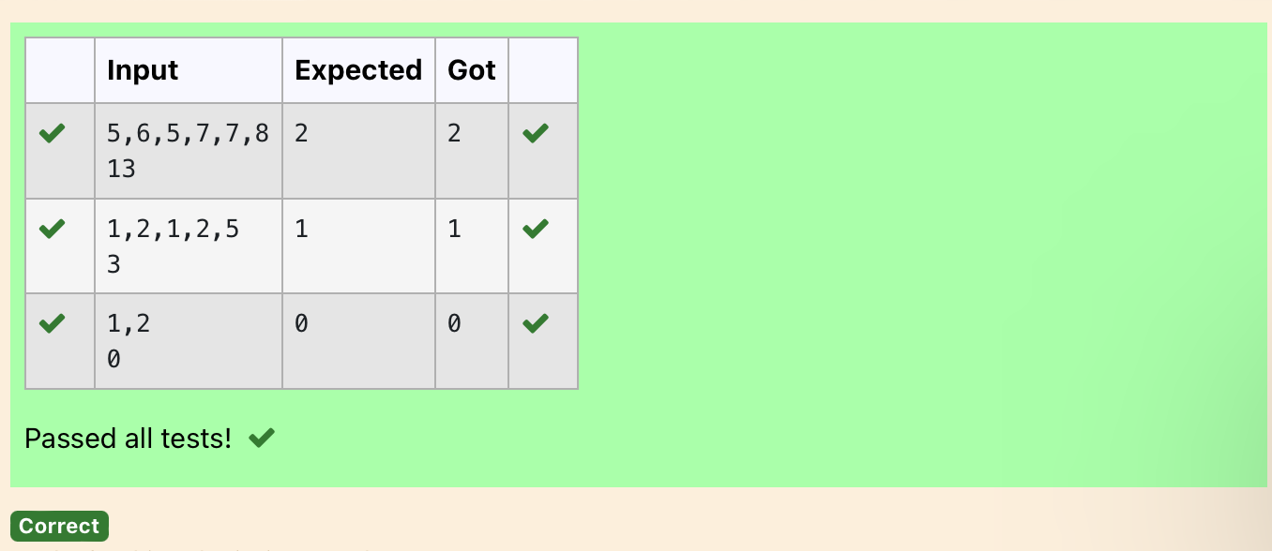

**Ex. No. : 8.3 Date:** 27/4/24

**Dept of Artificial Intelligence and Machine Learning** | **Rajalakshmi Engineering College**

142

**Register No.:231501017 Name: ANTONY JADRIEN A**

## DNA Sequence

The **DNA sequence** is composed of a series of nucleotides abbreviated as 'A', 'C', 'G', and 'T'.

For example, "ACGAATTCCG" is a **DNA sequence**.

When studying **DNA**, it is useful to identify repeated sequences within the DNA.

Given a string s that represents a **DNA sequence**, return all the **10-letter- long** sequences (substrings) that occur more than once in a DNA molecule. You may return the answer in **any order**.

**Example 1:**

**Input:** s = "AAAAACCCCCAAAAACCCCCCAAAAAGGGTTT"

**Output:** ["AAAAACCCCC","CCCCCAAAAA"]

**Example 2:**

**Input:** s = "AAAAAAAAAAAAA"

**Output:** ["AAAAAAAAAA"]

**For example:**

|  |  |
| --- | --- |
| **Input** | **Result** |
| AAAAACCCCCAAAAACCCCCCAAAAAGGGTTT | AAAAACCCCC CCCCCAAAAA |

**PROGRAM**

s = input() sequence_length = 10 seen = {}

result = []

for i in range(len(s) - sequence_length + 1): sequence = s[i:i + sequence_length]

if sequence in seen: seen[sequence] += 1

else:

seen[sequence] = 1

for sequence, count in seen.items(): if count > 1:

result.append(sequence) for i in result:

print(i)

.

**Output:**

.

**Dept of Artificial Intelligence and Machine Learning** | **Rajalakshmi Engineering College**

143

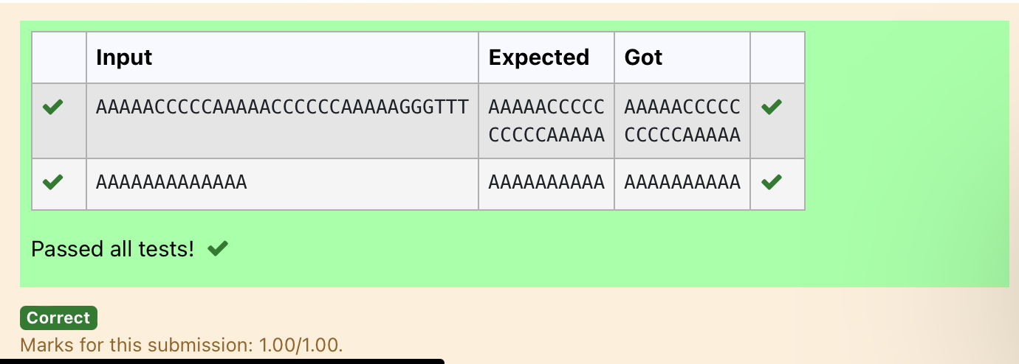

.

**Dept of Artificial Intelligence and Machine Learning** | **Rajalakshmi Engineering College**

144

**Ex. No. : 8.4 Date:** 27/4/24

**Register No.:231501017 Name: ANTONY JADRIEN A**

## Print repeated no

Given an array of integers nums containing n + 1 integers where each integer is in the range [1, n] inclusive.There is only **one repeated number** in nums, return *this repeated number*. Solve the problem using [set](http://118.185.187.137/moodle/mod/resource/view.php?id=734).

##### Example 1:

**Input:** nums = [1,3,4,2,2]

**Output:** 2

##### Example 2:

**Input:** nums = [3,1,3,4,2]

**Output:** 3

##### For example:

|  |  |
| --- | --- |
| **Input** | **Result** |
| 1 3 4 4 2 | 4 |

**PROGRAM**

st=input()

nums=st.split() for i in nums:

if nums.count(i)==2: b=nums.index(i)

print(nums[b])

Output:

.

**Dept of Artificial Intelligence and Machine Learning** | **Rajalakshmi Engineering College**

145

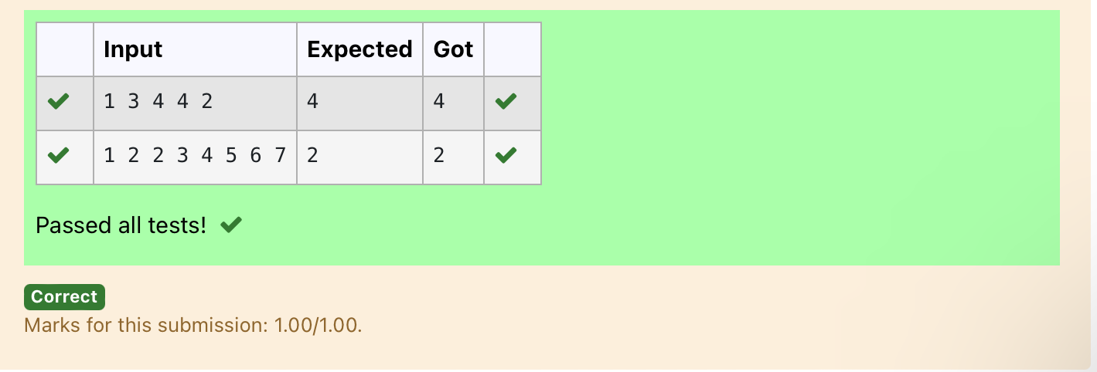

**Ex. No. : 8.5 Date:** 27/4/24

**Dept of Artificial Intelligence and Machine Learning** | **Rajalakshmi Engineering College**

146

**Register No.:231501017 Name: ANTONY JADRIEN A**

## Remove repeated

Write a program to eliminate the common elements in the given 2 arrays and print only the non-repeating elements and the total number of such non-repeating elements.

Input Format:

The first line contains space-separated values, denoting the size of the two arrays in integer format respectively.

The next two lines contain the space-separated integer arrays to be compared.

[Sample](https://www.rajalakshmicolleges.net/moodle/mod/quiz/view.php?id=5127) Input:

5 4

1 2 8 6 5

2 6 8 10

[Sample](https://www.rajalakshmicolleges.net/moodle/mod/quiz/view.php?id=5127) Output:

1 5 10

3

**For example:**

|  |  |
| --- | --- |
| **Input** | **Result** |
| 5 4  1 2 8 6 5  2 6 8 10 | 1 5 10  3 |

**PROGRAM**

sizes = list(map(int, input().split())) arr1 = list(map(int, input().split())) arr2 = list(map(int, input().split())) set1 = set(arr1)

set2 = set(arr2) unique1 = set1 - set2 unique2 = set2 - set1

unique_elements = list(unique1) + list(unique2) if unique_elements:

print(" ".join(map(str, unique_elements)))

print(len(unique_elements)) else:

print("NO SUCH ELEMENTS")

.

**Output:**

.

**Dept of Artificial Intelligence and Machine Learning** | **Rajalakshmi Engineering College**

147

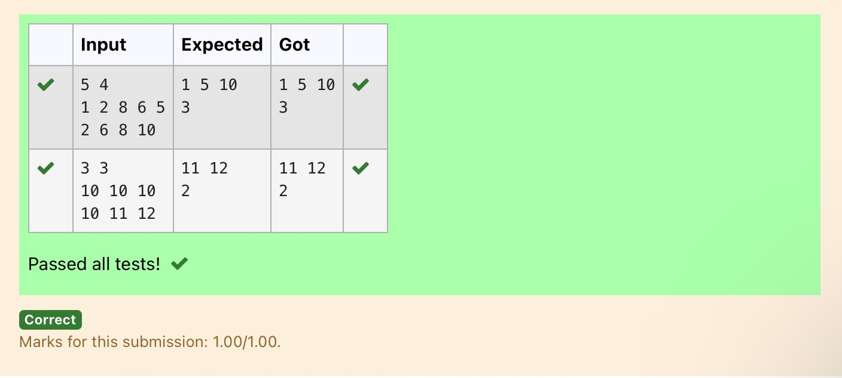

**Dept of Artificial Intelligence and Machine Learning** | **Rajalakshmi Engineering College**

148

**Ex. No. : 8.6 Date:** 27/4/24

**Register No.:231501017 Name: ANTONY JADRIEN A**

## Malfunctioning Keyboard

There is a malfunctioning keyboard where some letter keys do not work. All other keys on the keyboard work properly.

Given a string text of words separated by a single space (no leading or trailing spaces) and a string brokenLetters of all distinct letter keys that are broken, return the number of words in text you can fully type using this keyboard.

Example 1:

Input: text = "hello world", brokenLetters = "ad" Output:

1

Explanation: We cannot type "world" because the 'd' key is broken.

##### For example:

|  |  |
| --- | --- |
| **Input** | **Result** |
| hello world ad | 1 |

**PROGRAM**

s1=str(input()) s2=str(input()) l1=(s1.lower()).split(' ') l2=list(s2)

for i in l2:

for word in l1:

if i in list(word): l1.remove(word)

print(len(l1))

.

Output:

.

**Dept of Artificial Intelligence and Machine Learning** | **Rajalakshmi Engineering College**

149

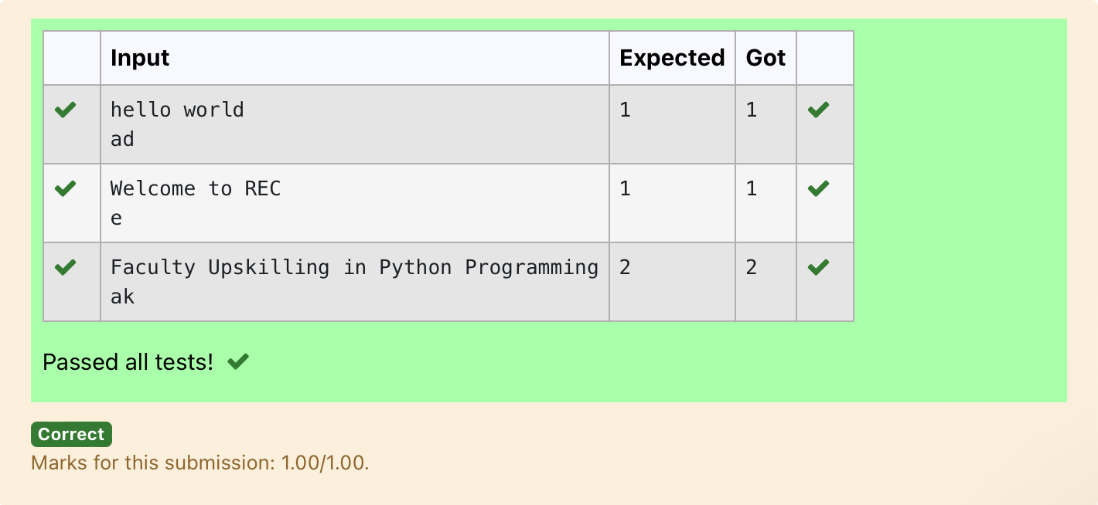

.

**Dept of Artificial Intelligence and Machine Learning** | **Rajalakshmi Engineering College**

150

**Ex. No. : 8.7 Date:** 27/4/24

**Register No.:231501017 Name: ANTONY JADRIEN A**

## American keyboard

Given an array of strings words, return *the words that can be typed using letters of the alphabet on only one row of American keyboard like the image below*.

In the **American keyboard**:

* the first row consists of the characters "qwertyuiop",
* the second row consists of the characters "asdfghjkl", and
* the third row consists of the characters "zxcvbnm".

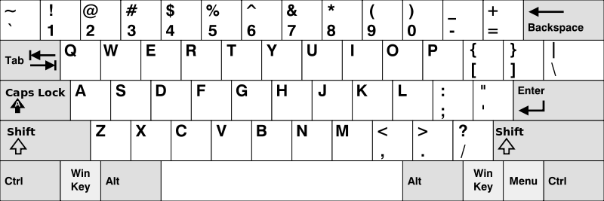

##### Example 1:

**Input:** words = ["Hello","Alaska","Dad","Peace"]

**Output:** ["Alaska","Dad"]

##### Example 2:

**Input:** words = ["omk"]

**Output:** []

##### Example 3:

**Input:** words = ["adsdf","sfd"]

**Output:** ["adsdf","sfd"]

.

**Dept of Artificial Intelligence and Machine Learning** | **Rajalakshmi Engineering College**

151

##### For example:

|  |  |
| --- | --- |
| **Input** | **Result** |
| 4  Hello Alaska Dad Peace | Alaska Dad |

**PROGRAM**

n=int(input()) l=[]

for j in range(n): l.append(str(input()))

row1 = set("qwertyuiop") row2 = set("asdfghjkl") row3 = set("zxcvbnm") result = []

for word in l:

lower_word = set(word.lower())

if lower_word <= row1 or lower_word <= row2 or lower_word <= row3: result.append(word)

if(len(result)!=0):

for i in range(len(result)): print(result[i])

else:

print("No words")

Output:

.

**Dept of Artificial Intelligence and Machine Learning** | **Rajalakshmi Engineering College**

152

